The Wolfson SPaRC (Sensory, Pain and Regeneration Centre) at King’s College London, Guy’s Hospital Campus hosted an outreach programme for A-Level students looking for practical work experience in a research lab within a university environment. The programme was held for 5 days in the summer of 2023 and was generously sponsored by the Biochemical Society. At King’s College London, we strive for inclusivity and diversity, including our placement students, and we pro-actively sought participation of students from local schools with a high proportion of students from disadvantaged backgrounds and from backgrounds that are underrepresented at university.
The programme was a mix of hands-on lab sessions, introductory talks to different research themes, and tours of core research facilities. Students received the opportunity to learn from and interact with scientists at many stages of their careers who led various sessions on the programme (technical staff, research assistants, PhD students, postdoctoral researchers, lecturers, professors and clinicians), with the aim of providing a flavour of university life and a career in biomedical science, medical research and medicine.
This year, we had 12 students (10 sponsored by the Biochemical Society and 2 matched funding from other sources) from 8 different schools, who were studying various STEM subjects at A-level with an interest in pursuing science or medicine. The outreach grant funded the students’ travel from across London, which was important since travel costs incurred often mean that students from disadvantaged backgrounds can be excluded from participating in programmes like this. The Outreach Grant also provided necessary lab equipment and materials for the students to carry out their experiments. The students learned about different research themes including pain, hearing and sensory systems and central nervous system disease, injury and regeneration. They performed various experiments such as cell culture, PCR and western blotting, histology and microscopy as well as translational science such as participant research.
A wide range of volunteers from the Wolfson SPaRC at many academic levels (from undergraduate students to Professors) helped the successful running of this programme through donating their time, resources and space. We are thankful for our Guy’s Campus facility managers from the Nikon Imaging Centre, Anatomy Dissection Room, the Centre for Biomolecular Spectroscopy and other campus staff for taking time to showcase the core facilities available and how they aid many research projects. The organisers, Professor Elizabeth Bradbury, Dr Leanne Lu and Mr Chris Bottoms would like to thank everyone involved for their time and effort in supporting this activity, as well as the Biochemical Society for making this possible. In the future we would like to grow this into a larger scale programme.
Feedback received from the students was unanimously positive (with an average 9.6/10 rating). Some positive aspects of the feedback were that the sessions were relevant to their studies, they enjoyed the opportunity to interact with various people in different careers and the highlight of the week were the practical sessions. To improve the programme further in subsequent years, we will take on board the comments of some students who wished the practical sessions were longer!

Some feedback quotes:
I liked the lab practicals the most, and the staff were so nice and excited and helped with questions and methods. I liked the different range of activities (tours, labs, facilities etc) and I learn so much useful information.
I want to do medicine but I loved being able to see the reality of research as it’s different to what I’ll read in a textbook. This experience has made me realise I actually have a strong interest in lab work and research.
Speaking to neuroscientists was just really enlightening. Getting to understand more how the research process actually works. Also the vibratome, cryostat and microtome were very fun for hands on experience.
I found the practicals really interesting and the sessions gave me an insight into the various types of research within neuroscience. Perfect length but I think the practicals could be a bit longer

Our work experience week has showcased the benefits of pursuing a career in science and/or medicine and given them valuable skills and experience for studying and/or working in a scientific research institute and at a university such as King’s College London. The programme was a great success, and we were delighted that the students found the experience enjoyable and hope that this will be beneficial to their careers and future university choices. We aim to keep in touch with the students following on from this experience to support them in their next steps towards applying to university. Of note, two of the students who attended the 2023 course have applied to King’s College London to study Neuroscience and Medicine.
We are extremely grateful to the Biochemical Society for making this project possible with a Scientific Outreach award.

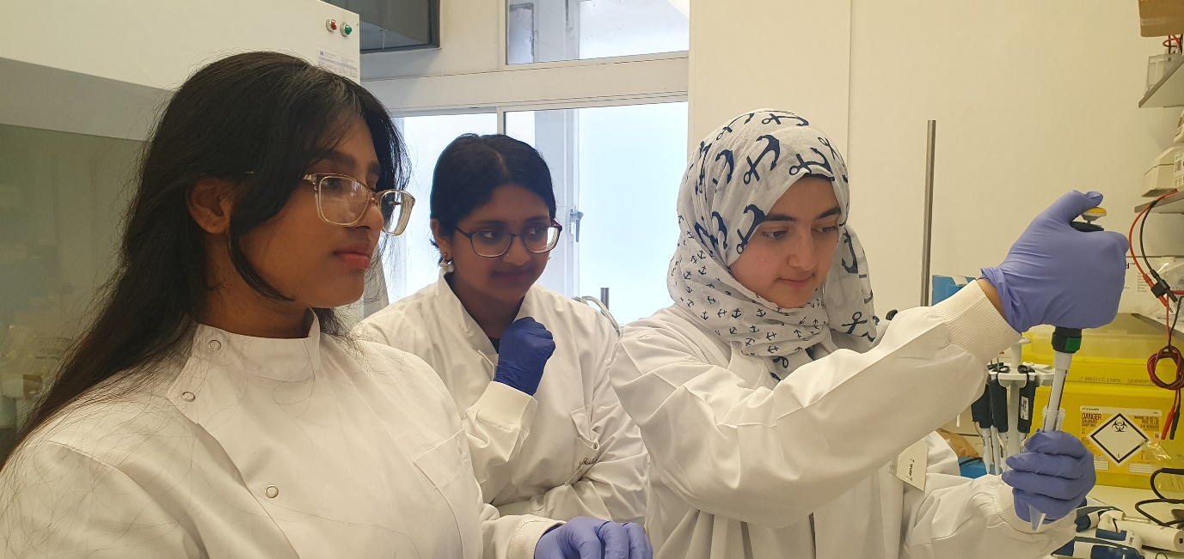
Figure 1 Students pipetting solutions for a genotyping practical

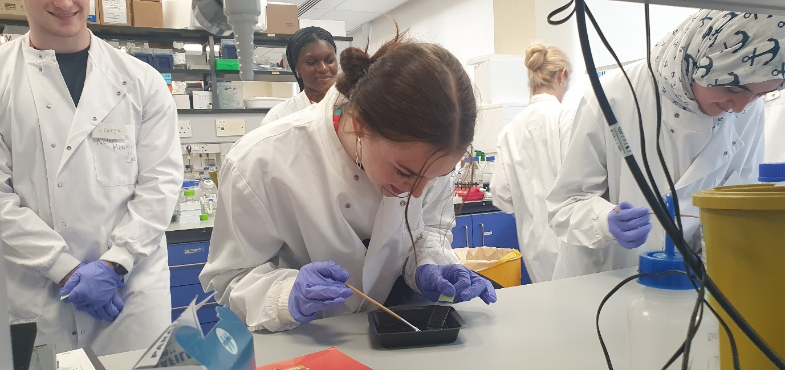
Figure 2 Students preparing slides with tissue slices
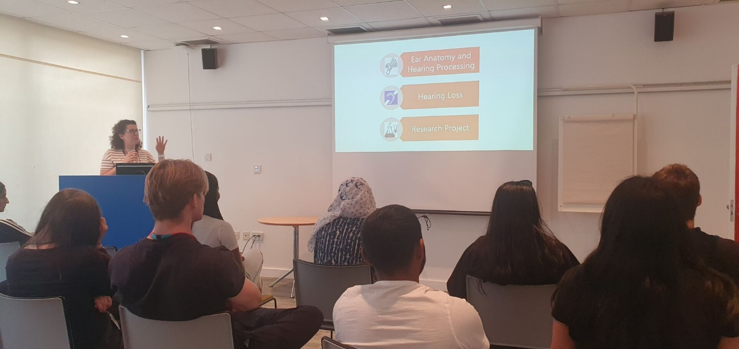
Figure 3 Introductory talk on hearing loss research
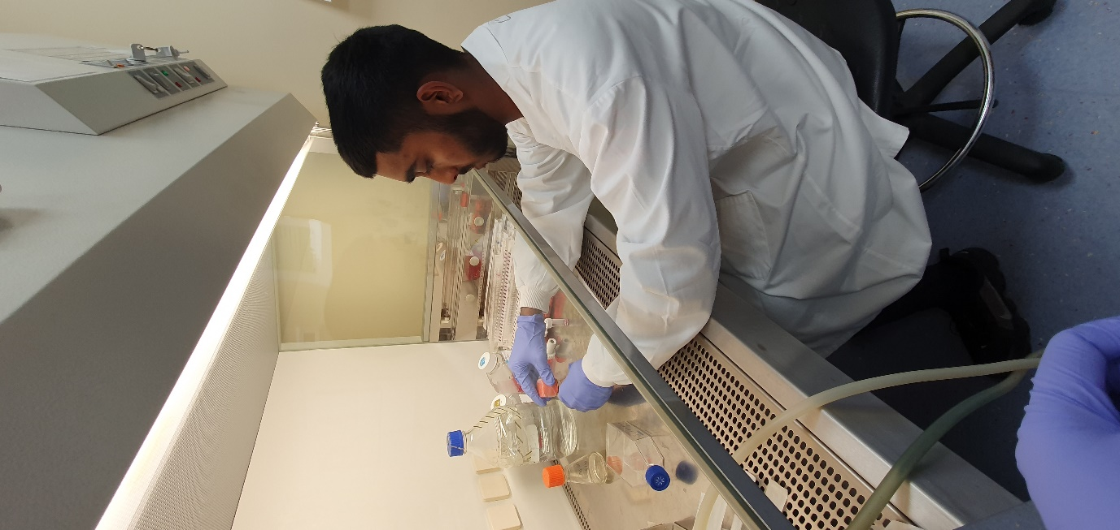
Figure 4 Student in microbiological cabinet passaging cells
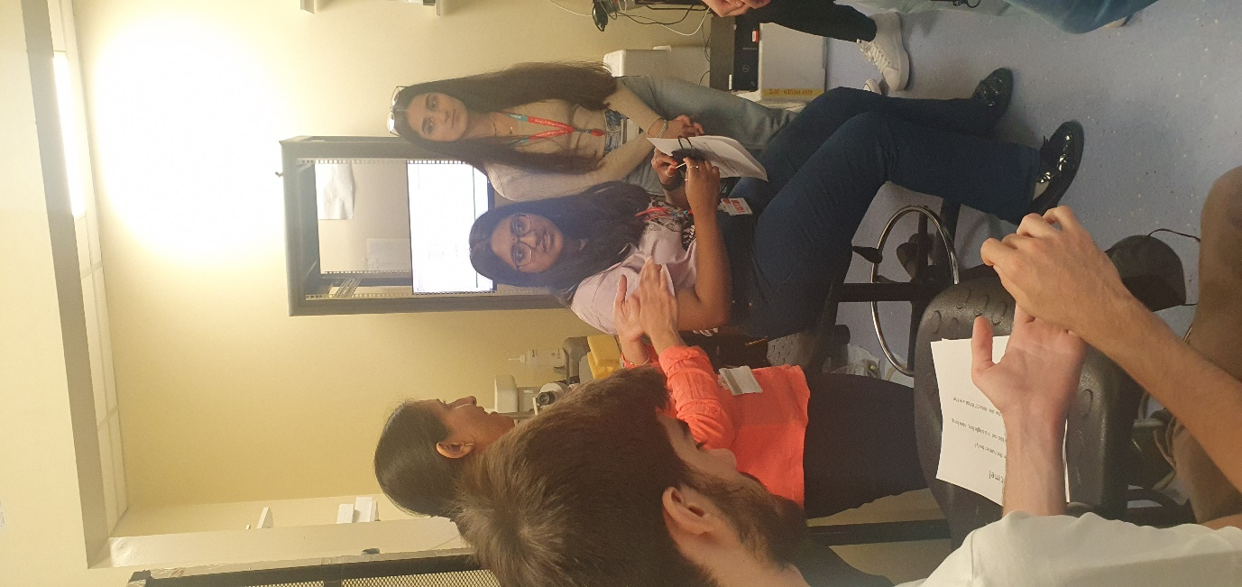
Figure 5 Students learning about sensory testing and electrophysiology
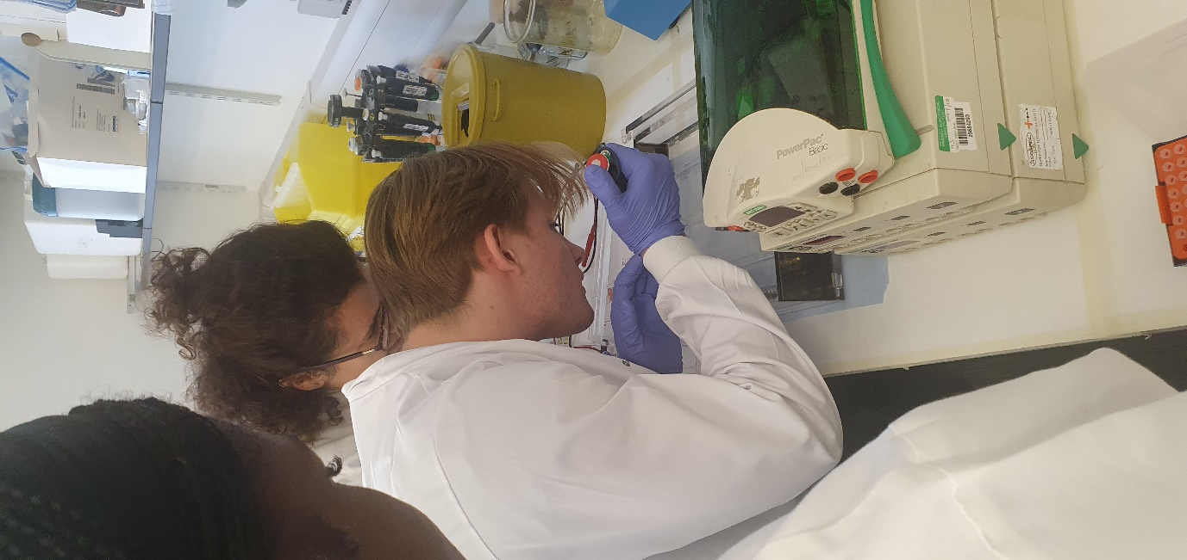
Figure 6 Students loading an agarose gel for gel electrophoresis
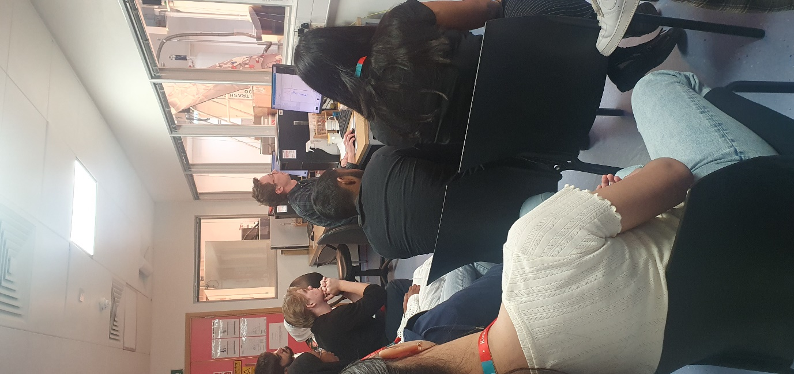
Figure 7 Introductory talk to Nuclear Magnetic Resonance facility
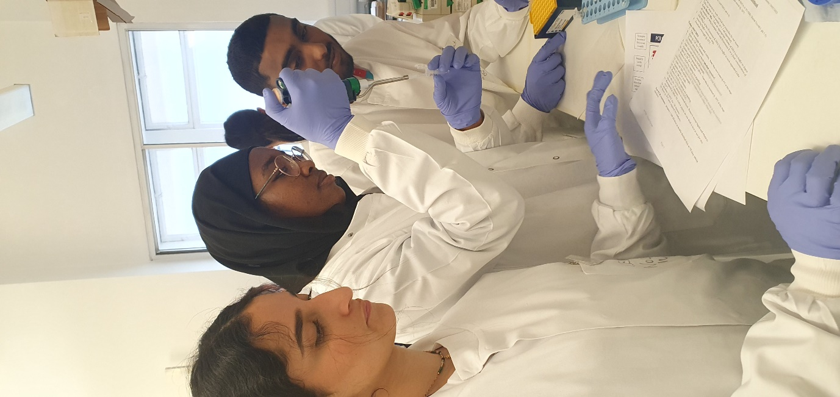
Figure 8 Students pipetting for genotyping practical
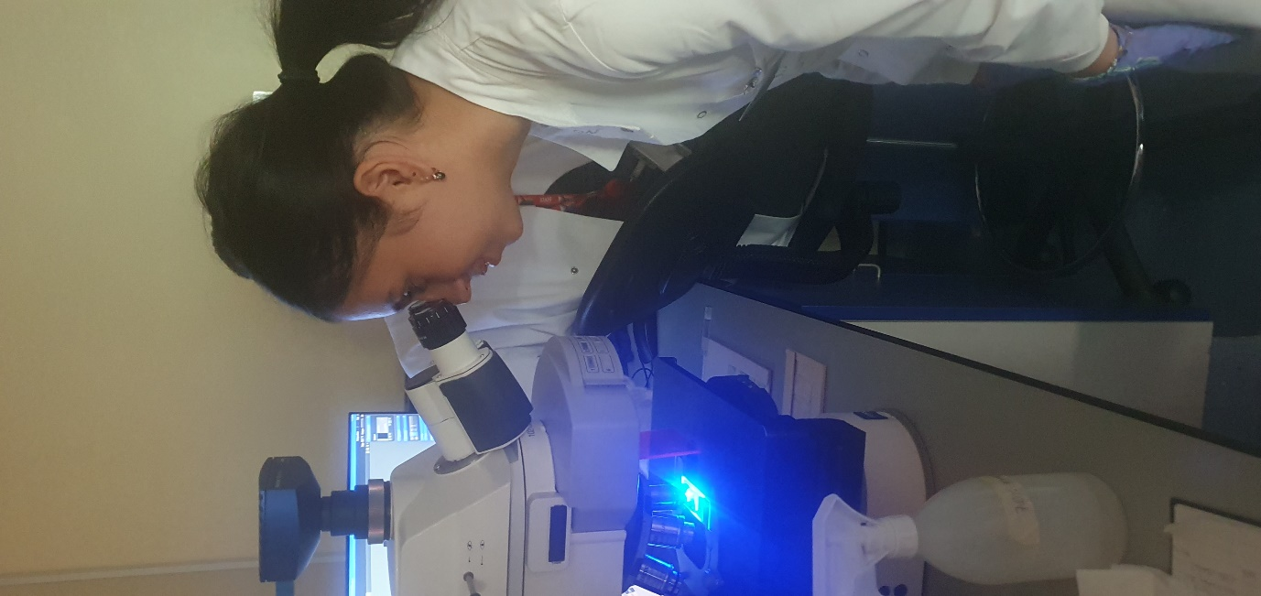
Figure 9 Students viewing fluorescence staining under a microscope
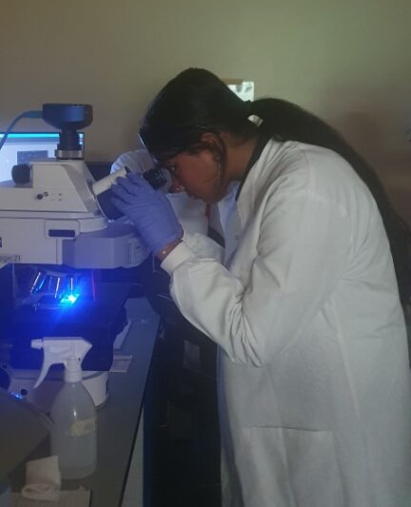
Figure 10 Students viewing fluorescence staining under a microscope
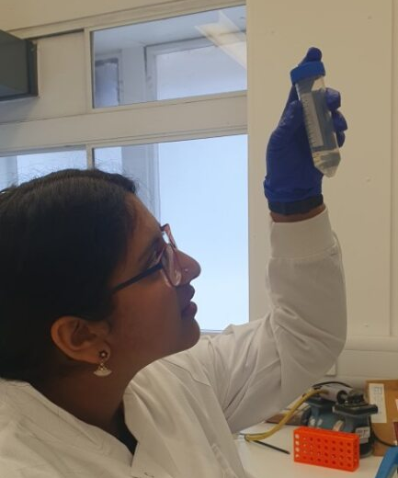
Figure 11 Student looking at a centrifuge tube with a solution inside
Pictures taken with consent from the students and their parents.

